**Onion Pathology Update**

Dr. Mary K. Hausbeck, 517-355-4534  
Michigan State University, Department of Plant, Soil & Microbial Sciences

Onions are plagued by serious leaf blights caused by fungal pathogens including *Stemphylium*. An aggressive pathogen in Michigan for the last couple of growing seasons, *Stemphylium* is not always readily controlled by the fungicide programs that limit purple blotch. Newly registered fungicides may offer some assistance to limit Stemphylium leaf blight and were evaluated (Table 1).

**Table 1.** Products tested.

| **Product** | **Active ingredient** | **FRAC code1** | **Labeled** |
| --- | --- | --- | --- |
| Aprovia Top EC | difenoconazole/benzovindiflupyr | 3/7 | yes |
| Bravo WeatherStik SC | chlorothalonil | M05 | yes |
| Cabrio WG | pyraclostrobin | 11 | yes |
| Luna Experience SC | fluopyram/tebuconazole | 7/3 | yes |
| Luna Sensation SC | fluopyram/trifloxystrobin | 7/11 | no |
| Manzate Pro-Stick DF | mancozeb | M03 | yes |
| Omega SC | fluazinam | 29 | yes |
| Pristine WG | pyraclostrobin/boscalid | 11/7 | yes |
| Quadris SC | azoxystrobin | 11 | yes |
| Quadris Top SC | azoxystrobin/difenoconazole | 11/3 | yes |
| Tebuzol 3.6F | tebuconazole | 3 | yes |
| Tilt EC | propiconazole | 3 | yes |

1Numbers and letters are used to define the fungicide groups by their mode of action. M=multi-site inhibitors. Visit www.frac.info for more information about FRAC codes.

**Evaluation of fungicides for control of Stemphylium leaf blight of onion.**

This study was conducted at a grower cooperator’s farm in Hamilton, MI. Onion ‘Bradley’ seeds were sown 21 April on raised beds that were 6 inches tall and 60 inches wide at the top and spaced 80 inches apart at the row center. Each bed consisted of eight rows of planting spaced 6 inches apart and seeds were spaced 2 inches apart within a row. A completely randomized block design with four replicates was established in an area 100 feet long by seven beds. Each treatment was 20 feet long with a 2-foot buffer section between replicates within a row. Fertilization, weeds and insects were managed by the grower cooperator and were to commercial production standards. Treatments were applied as a foliar spray on 22 and 27 June; 3, 10, 17, and 25 July; and 1, 9, and 15 August. The treatments were applied using a CO2 backpack sprayer and a broadcast boom equipped with three XR8003 flat-fan nozzles, spaced 18 inches apart, calibrated at 50 psi and delivering 50 gal/A. Disease severity was assessed as the severity of necrotic tissue (0 to 100%) on 31 July; 10, 17 and 24 August from the center 10 feet of the four rows of the treatment plots. Onions from 6 feet of the center four rows of the treatment plots were harvested on 10 September. The bulbs were allowed to dry, then topped, graded, and weighed on 8 October. Data were analyzed using an analysis of variance, with means separation performed using Fisher’s protected least significant difference (LSD).

At the first rating date, disease incidence in the untreated control was similar to the following treatments: Quadris SC, Manzate Pro-Stick DF, and Cabrio WG (Figure 1). Disease had progressed rapidly by the second rating with the untreated control presenting 76.3% necrotic tissue. All treatments resulted in less disease that the untreated control on 6 August except Manzate Pro-Stick DF and Cabrio WG. Disease protection began to deteriorate in additional treatments by the third rating on 14 August: Quadris SC, Pristine WG, and Tebuzol SC as well as Manzate Pro-Stick DF and Cabrio WG no longer limited disease in comparison to the untreated control. Meanwhile, Luna Sensation SC and Luna Experience SC limited disease incidence below 50%. At the final rating date, only Luna Experience SC provided acceptable disease protection at 52.5% necrotic tissue. Luna Experience SC also produced the highest total yield as well as the lowest yield of small bulbs, and the highest yield of both medium and large bulbs.

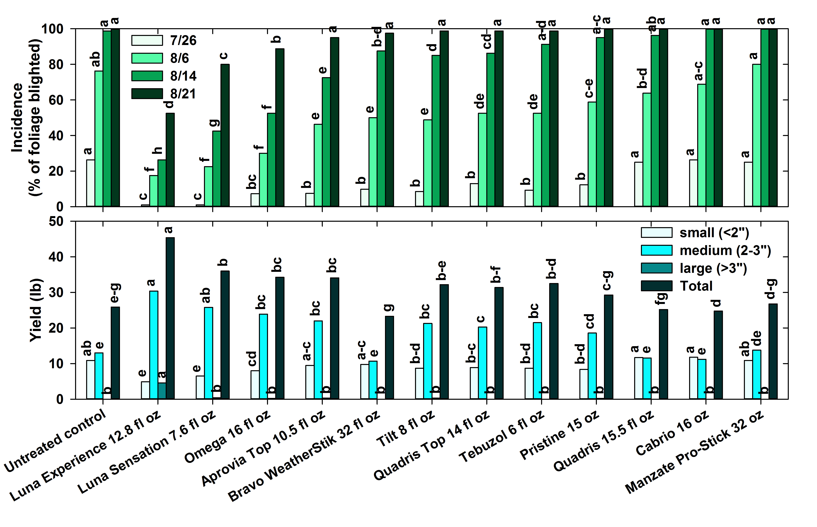

**Figure 1.** Evaluation of fungicides for control of Stemphylium leaf blight on onion: Top graph, disease incidence. Bottom graph, yield. Same-colored bars with a letter in common are not significantly different (t Test LSD; P=0.05).

This research was supported by Project GREEEN GR18-073 and the Michigan Onion Committee.